**SOUTHEAST UNIVERSITY**



**Department of Computer Science Engineering**

**PROJECT NAME: Mess management system**

**Course Code: CSE3012 Course Title: Database Design Lab**

**Submitted TO: Kimia Aksir**

**Designation: Lecturer**

**Submitted By: Name: Ahamadul Kabir tashfiq  
 ID: 2017000000072**

**Batch: 45th**

**Section: 06**

**Name: Md.Arif Hossain  
 ID: 2017000000004**

**Batch: 45th**

**Section: 06**

**Submission Date: 06-08-2019**

**Mess management system**

ER-Diagram:

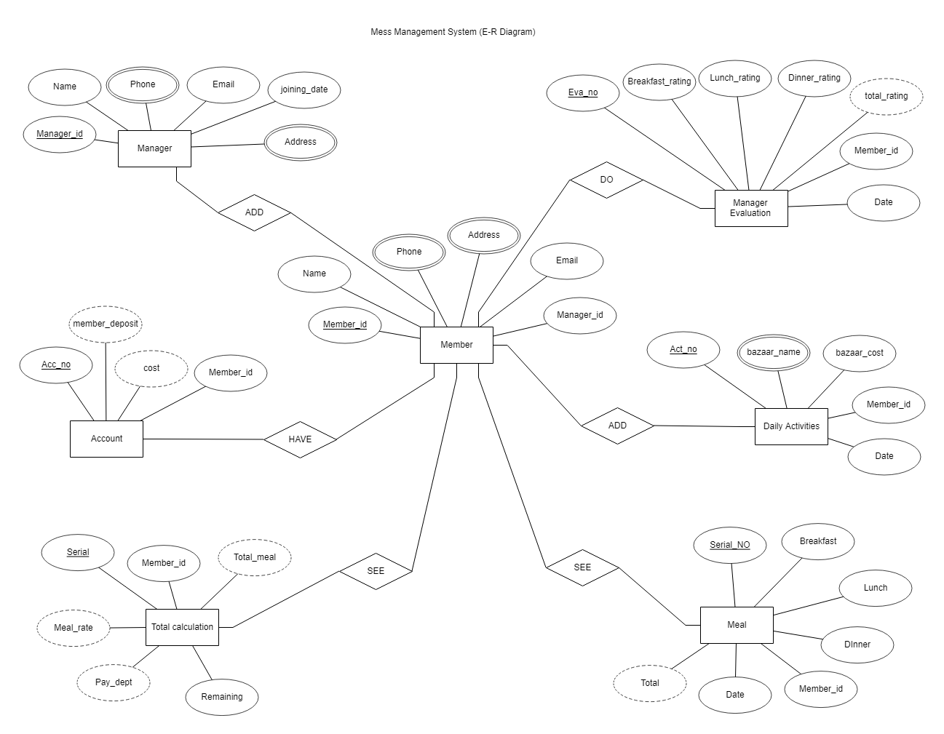

Generally, most of the student passing there are student life live in the mess. To live in the mess, they have to follow some rules and regulation. The most important and biggest rule is, each of every mess member has to take the entire responsibility of the mass in individual month. He has to manage the entire ‘Mess management system’. Who manage the entire system we called him ‘Manager’. He has to manage lot of things, such as:

1. Add new member.
2. Manage account.
3. Check daily activities
4. Paying attention to meals
5. Total calculation.

A manager has to notice this thing every day. Which is really boring and painful.

So, this is the purpose that we think to create a ‘Mess Management System’. Which is make this thinks easier and interesting. In our MMS (Mess Management System) we have added all features to make it easy for a manager. We use ‘MySQL’ database to store all the data.

Now we will provide some idea of our MMS (Mess management System): -

* A manager can add multiple member in the mess.
* Member add daily activities in the system.
* Member have an account Manager handle the account and total calculation through the member.
* Member see the number of meal to corresponding the date.
* Members can evaluate the manager and manager just only can see the evaluation rate.
* Every member can just only can see the position of account, number of meal and total calculation.

This are the features we have add in our ‘Mess management System’.

**List of Entity & Attribute:**

**Creating ‘Manager’ table:**

CREATE TABLE Manager (

manager_id varchar (20) PRIMARY key,

name varchar (50) not null,

phone varchar (30) not null,

email varchar (50),

address varchar (100) not null,

joining_date date not null);

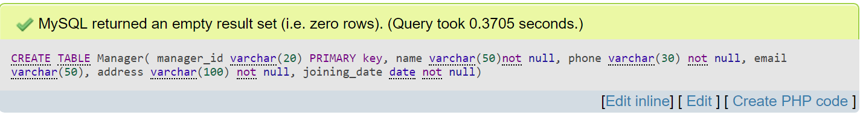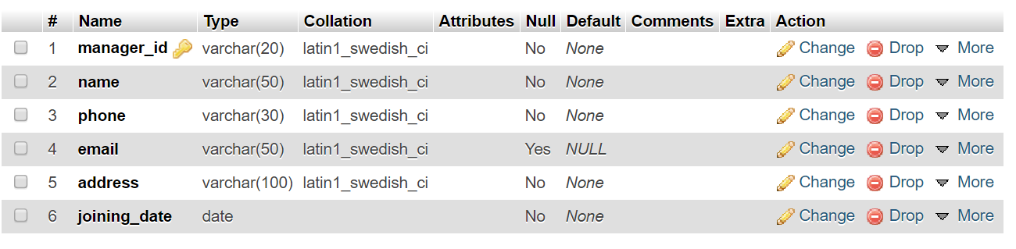

**Creating ‘Member’ table:**

CREATE TABLE member(

member_id varchar(20) PRIMARY key,

name varchar(50) not null,

phone varchar(20) not null,

email varchar(50) not null,

address varchar(100)not null,

manager_id varchar(20) not null,

FOREIGN key member(manager_id) REFERENCES manager(manager_id)

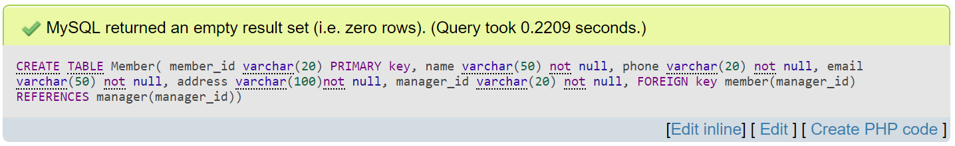

**Creating ‘Manager Evaluation’ table:**

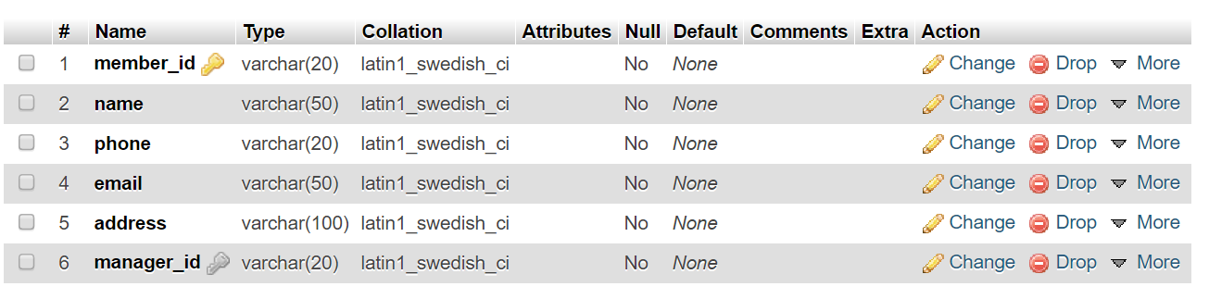

CREATE TABLE manager_evaluation(

eva_no int(20) PRIMARY key AUTO_INCREMENT,

member_id varchar(20) not null,

breakfast_rating int(10)not null,

launch_rating int(10)not null,

dinner_rating int(10)not null,

total_ratig int(10) not null,

FOREIGN KEY (member_id) REFERENCES member(member_id)

);

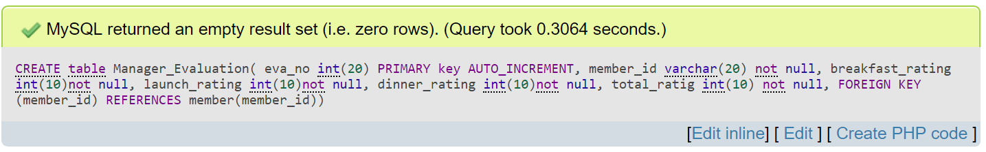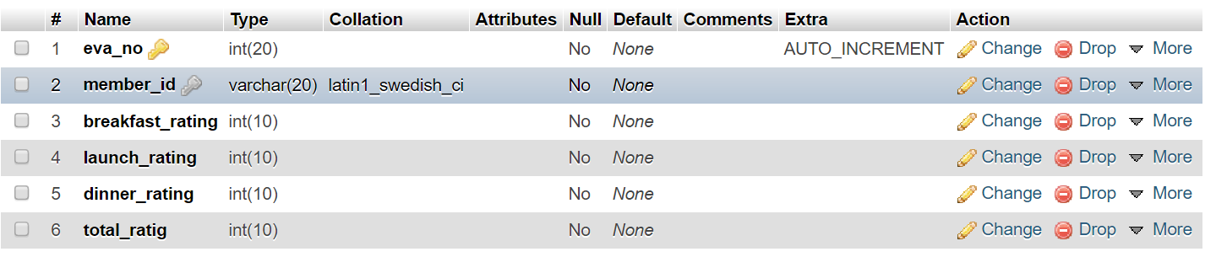

**Creating ‘Daily Activity’ table:**

CREATE TABLE daily_activity (

Act_no int(20) PRIMARY key AUTO_INCREMENT,

bazar_name varchar(50) not null,

bazar_cost double(10,3) not null,

member_id varchar(20) not null,

FOREIGN key (member_id) REFERENCES member(member_id));

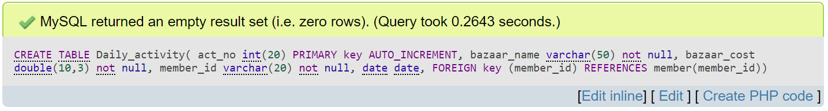

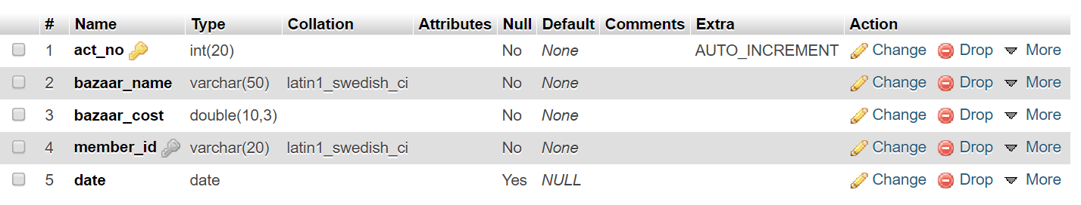

**Creating ‘Meal’ table:**

CREATE TABLE meal(

serial_no int(20) PRIMARY key,

member_id varchar(20),

breakfast int(10),

launch int(10),

dinner int(10) ,

total int(10) not null,

date date,

FOREIGN key (member_id) REFERENCES member(member_id)

);

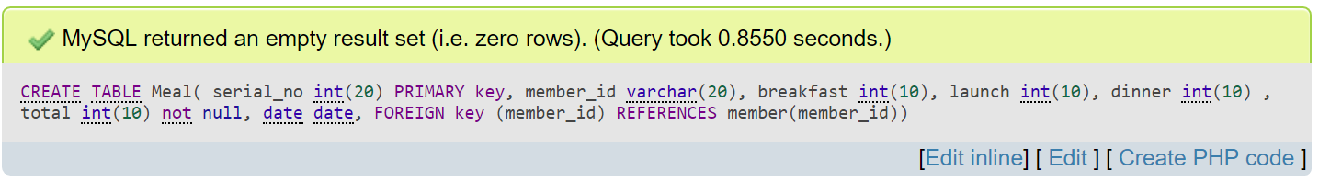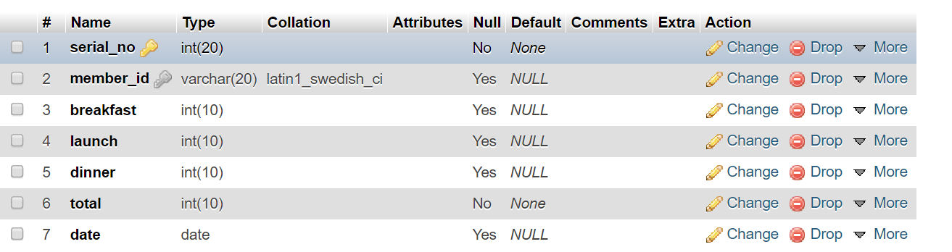

**Creating ‘Total calculation’ table:**

CREATE TABLE total_calculation(

serial int(20) PRIMARY key AUTO_INCREMENT,

member_id varchar(20),

total_meal int(10) not null,

meal_rate double(10,3)not null,

pay_dept double(10,3),

remaining double(10,3),

FOREIGN key (member_id) REFERENCES member(member_id)

);

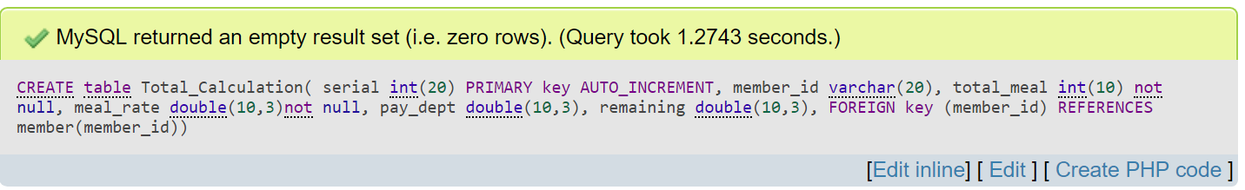

**Creating ‘Account’ Table:**

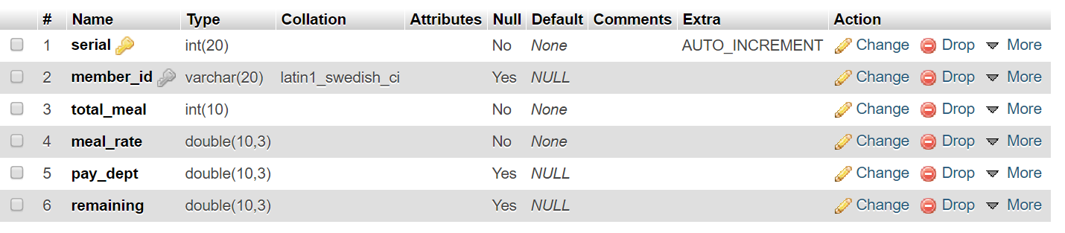

CREATE TABLE account(

acc_no varchar(20) PRIMARY key,

cost double(10,3) not null,

member_deposite double(10,3),

member_id varchar(20) not null,

FOREIGN key account(member_id) REFERENCES member(member_id)

);

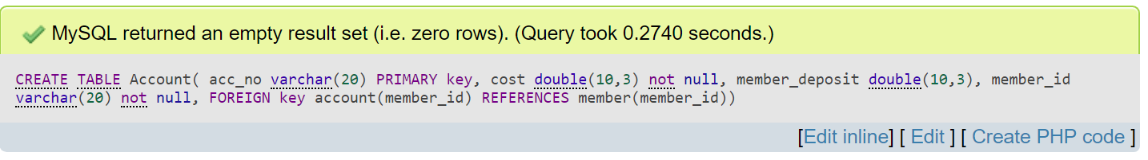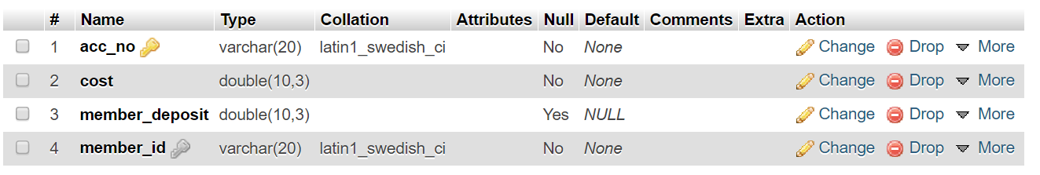

**Creating ‘view’:**

**Create Member View:**

CREATE VIEW Member_view

as SELECT m.name, me.total , c.member_deposit

FROM member m, meal me, account c

WHERE m.member_id = me.member_id

AND m.member_id = c.member_id;

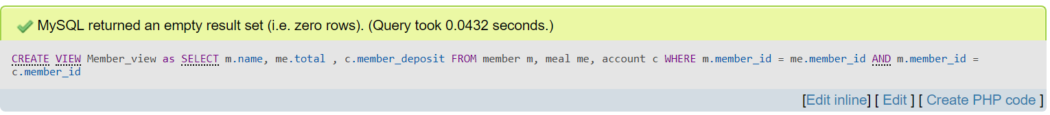

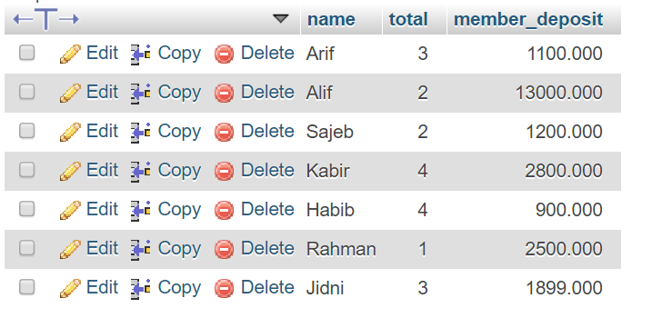

* **Create Member Info View:**

CREATE VIEW MEMBER_INFO

AS SELECT m.member_id,m.name,me.total,ac.cost,

ac.member_deposit as Deposit

FROM account ac,member m,meal me

WHERE m.member_id=ac.member_id AND m.member_id = me.member_id;

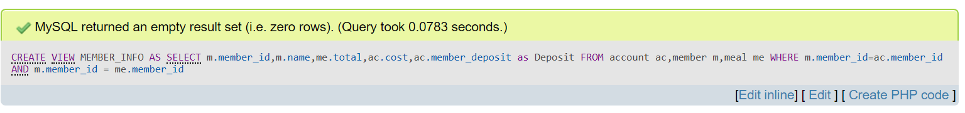

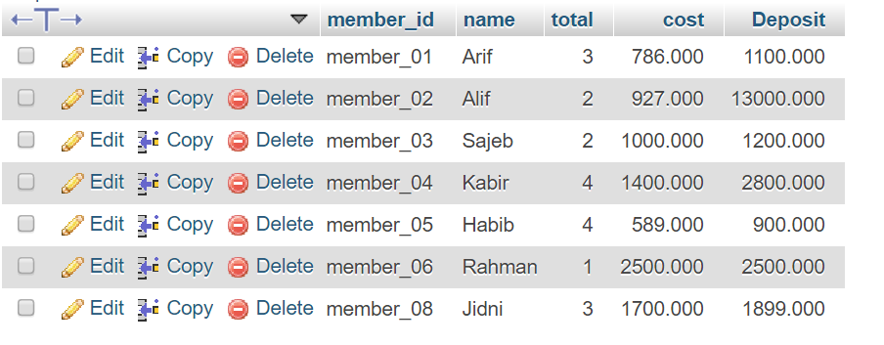

**Bazar with all information view:**

CREATE VIEW BAZAR

AS SELECT m.member_id,m.name,d.bazaar_name,d.bazaar_cost,d.date

FROM member m,daily_activity d

WHERE m.member_id=d.member_id;

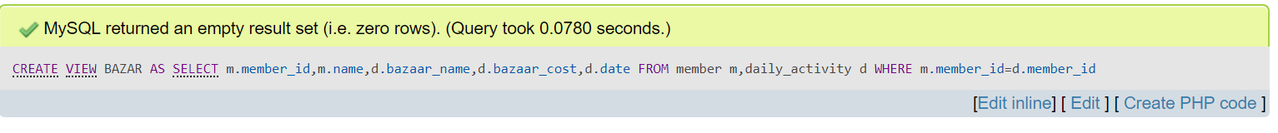

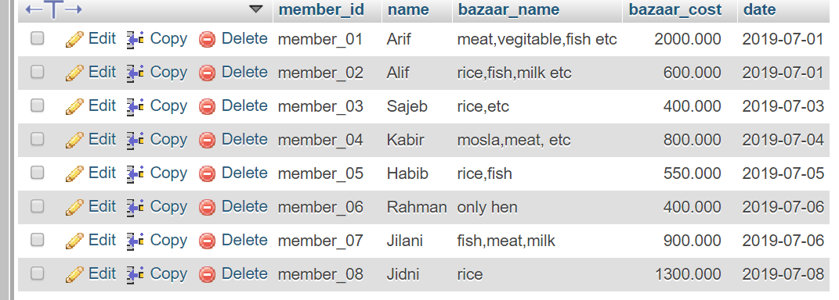

**List of Queries:**

**1.Alter column:**

ALTER TABLE manager_evaluation

add COLUMN date date;

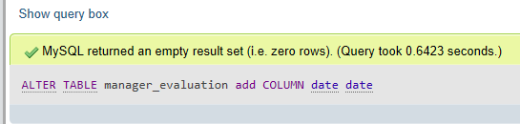

**2.Alter table:**

alter TABLE manager_evaluation

add CONSTRAINT

FOREIGN KEY member_id REFERENCES member(member_id);

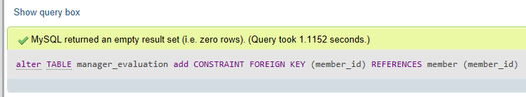

**3.Delete:**

DELETE FROM total_calculation

WHERE pay_dept = ‘0’;

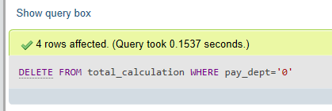

**4.Count of Joining multiTable:**

SELECT m.manager_id,m.m_name,COUNT(me.member_id)

FROM member me,manager m

WHERE me.manager_id=m.manager_id

GROUP BY manager_id;

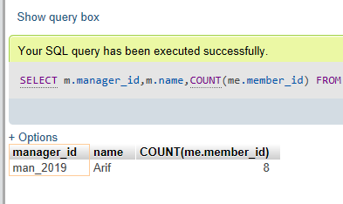

**5.** **Use of As,Like,Order by:**

SELECT bazaar_name AS name, bazaar_cost AS cost,member_id

FROM daily_activity

WHERE bazaar_name LIKE ('rice%') or bazaar_name LIKE('meat%')

ORDER BY member_id DESC

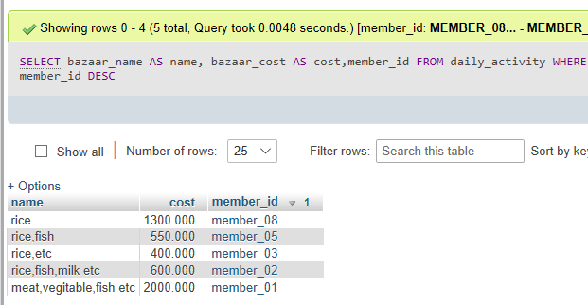

**6.Max finding of multiTable:**

SELECT m.member_id,max(e.total_ratig) AS Maximum

FROM manager_evaluation e,member m

WHERE m.member_id = e.member_id AND

date BETWEEN '2019-03-03' and '2019-03-08';

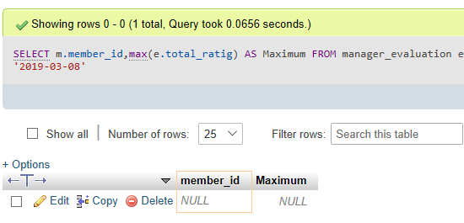

**7.Joining table:**

SELECT sum(m.total) AS total_MEAL,sum(d.bazaar_cost) AS Cost,sum(bazaar_cost)/sum(total) AS Rate

FROM daily_activity d,meal m ,member me

WHERE me.member_id=m.member_id AND

me.member_id=d.member_id;

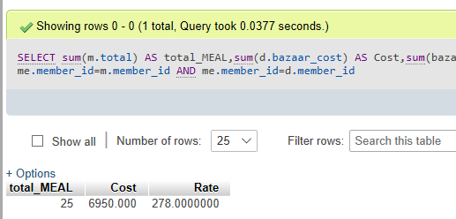

**8.Joining table:**

SELECT m.total, a.cost

FROM account a,meal m,member me

WHERE me.member_id=m.member_id AND

me.member_id=a.member_id AND

m.member_id='member_01';

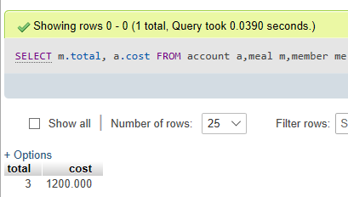

**9.Sum:**

SELECT sum(total) as TOTAL_MEAL

FROM meal;

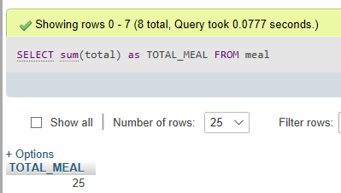

**10.Sum:**

SELECT sum(bazaar_cost) as TOTAL_COST

FROM daily_activity;

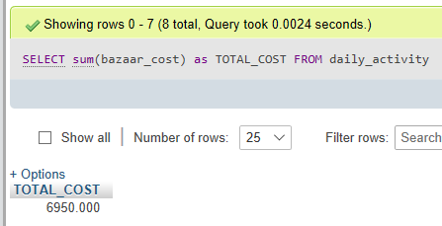

**11.Update data:**

UPDATE manager_evaluation

set date='2019-03-01';

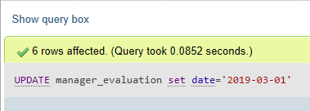

**12.Update data:**

UPDATE account

SET cost=524,member_deposite=1000

WHERE member_id='member_02';

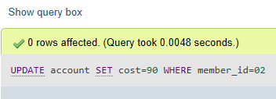

**13.Update data:**

UPDATE account

SET cost=786

WHERE member_id='member_01';

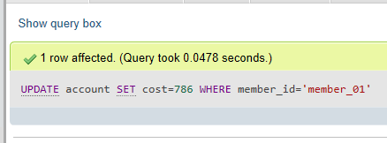

**14.Delete whose dept null:**

DELETE FROM total_calculation

WHERE pay_dept='0';

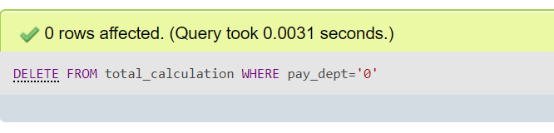

**15.Third max rating:**

SELECT m.manager_id AS Id,m.name AS Name,max(e.total_ratig) as THIRD_MAX

FROM manager_evaluation e,manager m,member me

WHERE e.total_ratig=(SELECT max(total_ratig) FROM manager_evaluation

WHERE total_ratig<(SELECT max(total_ratig) FROM manager_evaluation

WHERE total_ratig<(SELECT MAX(total_ratig) FROM manager_evaluation)))

AND me.manager_id=m.manager_id AND me.member_id=e.member_id;

